Assignment 2 SECPH 2523

QUESTION 1
Table 2.1 STUDENTFINE records data on traffic offences by students in acollege.
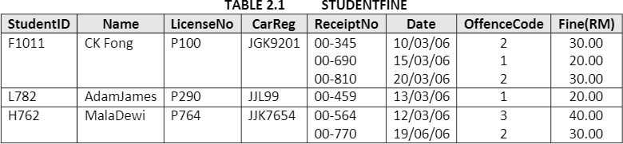
- Table 2.1 is said to be unnormalized table. Why?
- Transform the unnormalized Table 2.1 into a First Normal Form (1NF) table. Show the transformed 1 NF table. What is the primary key for this new 1 NF table.

QUESTION 2
The following table is un-normalized table that is created to manage a consulting company’s operations. Create its normalized forms (1NF, 2NF, and 3NF). Note: Define the PK and FK for each table:

Project number | Project name | Employee number | Employee name | Rate category | Hourly rate
1023 | Madagascar travel site | 11 | Vincent Radebe | A | $60
 |  | 12 | Pauline James | B | $50
 |  | 16 | Charles Ramoraz | C | $40
1056 | Online estate agency | 11 | Vincent Radebe | A | $60
 |  | 17 | Monique Williams | B | $50

